What Celebrities wear out of the Limelight?

Celebrity couple Aston Kutcher and Mila Kunis dressed down while out.
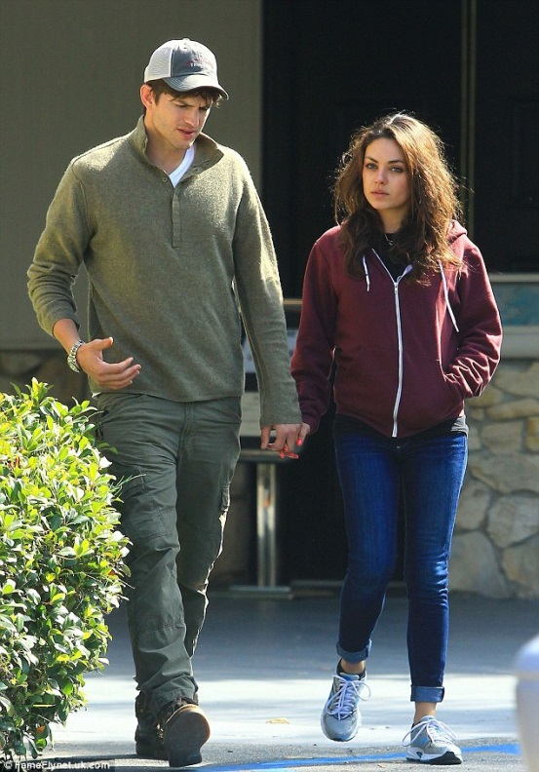
They may be one of Hollywood's most successful young couples, but Ashton Kutcher and Mila Kunis are happy to prove that being a movie star isn't always glamorous.

Wearing a purple zip-up hoodie with skinny jeans and trainers, Mila was casually unkempt and a distinct lack of make-up for the outing.
Meanwhile, Ashton opted to hide under a baseball cap while wearing khaki chinos and a green jumper. The only symbol of his acting fame was the silver Rolex on his right wrist. To me they both look like an everyday couple hitting the town as a couple in love as they hold hands.
Picture fromdailymail.co.uk

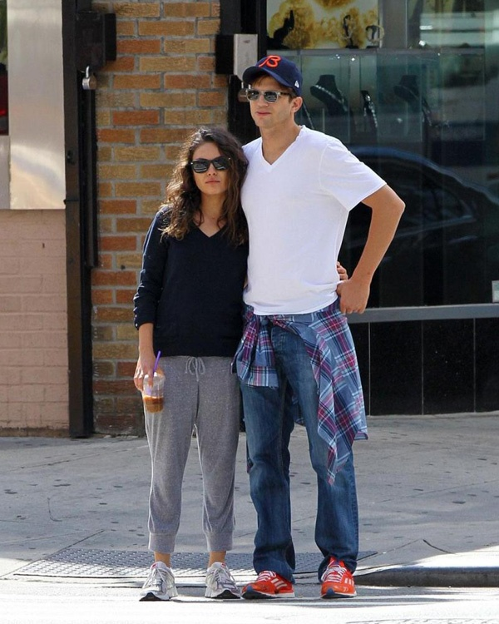
Yet again we see the lovely couple out in their town dressing down like and every day person like me and you. I know that how Ashton is dressed in a stylish white V-neck T-shirt and loose fitted blue jeans with his blue and red checked shirt tied around his waist. What I’ll ask you all reading this how many of us dress like this? He looks very casual with his trainers of orange and his cap and glasses.
Mila has as well dressed down and to be fair, would you recognise her if she walked down the street and passed you by. We can see that she wear a dark blue V-neck jumper and grey sweat pants that appear to be just a little short in the leg.
In my mind’s eye it is good to see that the famous people of the world are out dressing like me and you but probably the only difference is maybe the price of the clothes they wear to what we wear. As in the first picture the green combat pants he wears is the sort of thing I would wear on a daily basis but personally I would not wear the same colour jumper but maybe something like a black or white T-shirt.
Below we can see the pair out in the evening and Mila is wearing a casual but stylish fruit printed top which is a big hit with the younger generation. Ashton is wearing a Maroon cardigan with white pattern which kind of looks a little Christmassy but very nice. And it actually goes really well with his baseball cap.
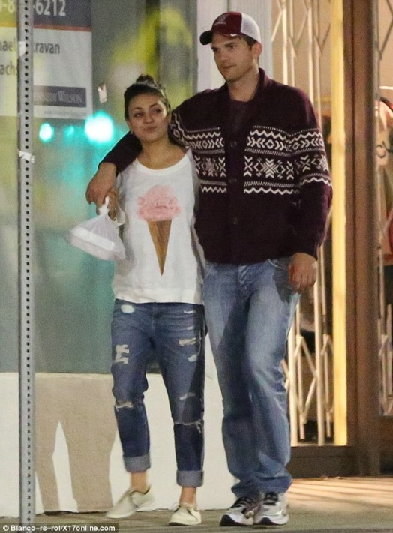
Picture from dailymail.co.uk
Now looking at what the pair of these celebrities were I can honestly say that this is the style of fashion I would actually wear myself on a daily basis. If you want something close to what they wear I’m sure if you shop around at the higher end of high street shops you would find the same or very close to it. It may be in different colours or slightly different style but they will look just as good. It is good to see that the well know celebrities dress like every none famous people like you and me. Now I will put down about what the celebrity couple would wear when they are in the limelight something like the red carpet.

What these two wear in the limelight.

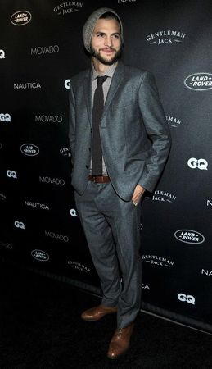
Ashton looking very sharp in a grey Hugo Boss suit and a Boss Black shirt with a grey tie and pulling it off with his grey beany hat. This was from an award for the hit show Two and a Half men. Ashton looks stylish but he manages to pull off the smart stylish look and down grading it with the hat.
How many of us could actually pull this off so easy. Is it because he is a famous celebrity or he is an actual fashion icon to some people. To me if I could pull this off I’d be happy with things I wear in a fashion sense.

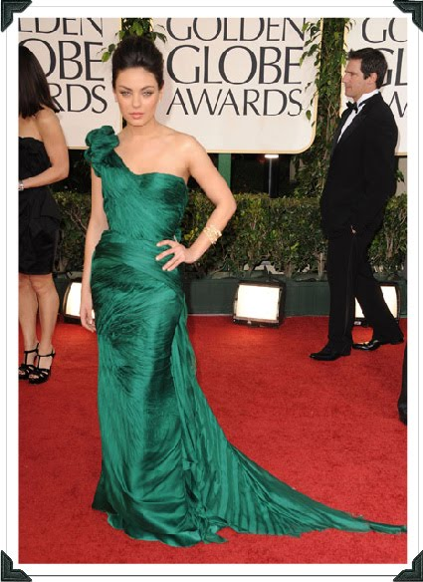
Hear we have Mila Kunis wearing a stunning Vera Wang Gown for the awards for The Golden Globes.
This is a stunning off the shoulder gown that she shows off with perfection with the big flower on the shoulder draws your eyes to the stunning gown. On her left wrist she is wearing a bracelet by Lorraine Schwartz which is made from diamonds. With the flowing trail it just screams out POW look at me and rightly so. This gown is top of the range in my opinion and it is just a shame there is not a picture with her handsome other half Ashton Kutcher.
So over all even though when the celebrities are in the limelight and look amazing they are also looking like every day regular people but still looking good. So to be fare they must have to live two lives being celebrities in and out of the limelight. It must be difficult being a celebrity being fashion icons to people, with people always looking at what they wearing. Thinking about will they get picked at for what they wear or is it a case of ‘we don’t care what people think’. I often think about this when I write, what it’s like to be a celebrity and wearing clothes that are for everyday or for big functions. Personally I wouldn’t mind trying to find out what it would be like on the fashion sense to be a celebrity.

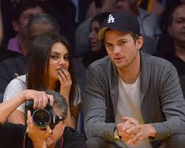
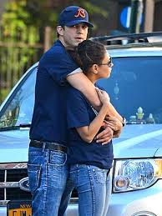
To be fair I have hunted a few sights around and when they are together they are usually dressed down together as these two photos show. It is nice in the second photo of them both hugging. They are both wearing very similar outfits and still looking good and stylish.

